Jake Hinson

History 100

4/2/16

Pictorial Essay

Idaho is called to over 2.3 million head of cattle. That means there are almost a million more cows in this state than there are people. Idaho also has a total of 11.8 million acres of farmland. Which means about 22% of this state is farmland. These numbers are not very large when compared to many other states; in fact we are ranked 13th for the amount of cattle, 24th for total farmland, and 39th for the amount of people. With that being said, Idaho has been crowned the largest state in the nation for water use per capita. This is why Idaho is considered to be one of the least responsible states with respect to water conservation.

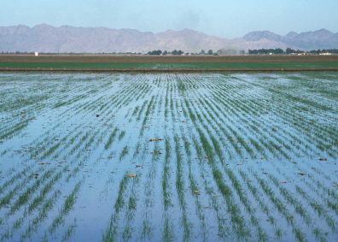 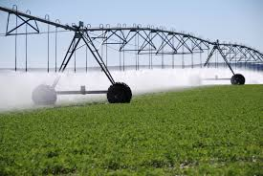 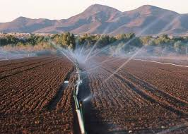

Irrigating is the most crucial part of farming and ranching. Without water, these professions would not be possible. There are many ways to irrigate for farmlands and each have their pros and cons. As seen on the left above, flood irrigation is pretty self explanatory; you flood your fields completely. Many farmers use pivots or wheel sprinklers just as seen in the picture in the middle. This is probably the most expensive way of irrigating your field, but it is also the most effective when considering the amount of water needed for this task. Another way many farmers irrigate their land can be seen above on the right, it is with the use of hand lines which are basically above ground sprinkler systems. This method probably requires the most work of all of the other methods.

Many factors come into play when farmers decide how they will be irrigating their crops. How much money are they willing to spend on equipment for irrigation? Farm equipment is far from affordable. Most farmers are fighting to keep their heads above water financially, and some of the equipment shown above can total hundreds of thousands of dollars. How much work will the equipment require to set up, and how much work will be required to keep them running? Most farmers have zero employees (if you don’t count their family and friends as employees) and during the summer they are running nonstop to ensure that they will produce enough crops to pay their bills. And a big question that will play a huge factor into a farmers decision, how much water do I have at my disposal for irrigation?

Farmers use such a large amount of water that the government makes them buy water rights. Water rights are purchased from the government and this gives farmers the right to make use of the water from streams, lakes, or irrigation canals. Idaho uses roughly 97% of its water for agriculture, meaning that only about 3% of the water used in this state is from urbanized areas. The comparison of acres of farmland to the population of Idaho is not 97% to 3%. So why are we allocating our water as if that is the case?

Idaho has lots of water at its disposal, especially when you compare it to other states such as California, Arizona, and New Mexico. However, there are more acres of farmland in those states than in Idaho. These states have had to struggle with their use of water, while Idaho floods their fields freely. Just because we have the water does not mean that we need to use it as if we will never run out. The way that Idaho uses its water needs to change, or we just might end up like our southern neighbors.

Bibliography

Ridler, Keith. "Study: Idaho Tops Nation in Water Use per Capita." 7KTVB.com. TEGNA, 14 Nov. 2014. Web. 2 Apr. 2016.

"List of States by Population." List of States By Population, Based on 2010 Census. 1keydata.com, 2016. Web. 06 Apr. 2016.

"Quickly Accessible, Concise Information about Each of the 50 States and the District of Columbia!" Farms. Moo-Chi LLC, 26 June 2013. Web. 02 Apr. 2016. <http://www.stuffaboutstates.com/agriculture/farm_by_total_acres.htm>.

Brentzel, Chealsea. "Eastern Idaho Cities Face Water Rights Issues." KIFI. NPG of Idaho, 10 Dec. 2015. Web. 02 Apr. 2016. <http://www.localnews8.com/news/eastern-idaho-cities-face-water-rights-issues/36904596>.